## Project Fajr

## [1. Introduction](https://www.al-islam.org/articles/al-fajr-sadiq-new-perspective-sayyid-muhammad-rizvi#1-introduction)

The daily prayers are an essential part of a Muslims life. In order to fulfill their religious obligation, it is important for all Muslims to know the timing of the prayers. Knowing the timing of the zuhr and maghrib prayers has never been a problem since it is common knowledge for most Muslims. The timing for the asr and isha prayers are also known as it can be found in any western observatory or astronomical institution timetable. However, determining the exact time for the Fajr prayer is not an easy task.

In the past, Muslims would turn to the mu'azzin of their neighborhood mosques to Know the time of the Fajr prayer, which depended on the human eye to recognize the time for Fajr prayer. Nowadays, many Muslims are living in cities with tall buildings which makes line of sight to the sun impossible to see. The visibility of dawn becomes even harder to observe with these obstacles on top of the uncertainty presented when the sun is located below the horizon, or on a rainy or cloudy day.

How do you define Fajr and how do you explain the difference between the False Dawn “Al-fajr al-kadib “and the True Dawn “Al-fajr Sa-sadiq” ?

In Project Fajr, we intend to make this time available to all Muslims throughout the world. With the help of Allah, the Quran and Sunnah and advancements in technology; Muslims will no longer need to rely on inaccurate definitions of twilights and multiple mobile/web application methods for calculating prayer time.

## 2[. Science & The Twilights](https://www.al-islam.org/articles/al-fajr-sadiq-new-perspective-sayyid-muhammad-rizvi#4-science-twilights)

From the scientific point of view, the light which appears before sunrise and remains after sunset is known as “twilight”. Twilight literally means “the light between the two,” i.e., between night and day or between day and night. In Arabic, “twilight” is known as “ash-shafaq.”

It is obvious that the light of morning twilight gradually increases in brightness; to distinguish the various stages of twilight, the scientists have divided it into three types of twilights as show in figure.4:

1. the Astronomical Twilight: this begins when the Sun's center is 18 degrees below the horizon.

2. the Nautical Twilight: this occurs when the Sun's center is at 12 degrees below the horizon.

3. the Civil Twilight: this occurs when the Sun's center is at 6 degrees below the horizon.

The third twilight known as the Civil Twilight is of no use for us as it is mostly used by civil authorities to decide when the streetlights and car head lights are no longer needed. Some scientists have given it the name of “head-lights twilight.”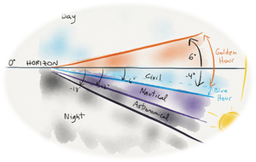

**Types of Twilight Figure.1**

According to the astronomers, the morning Astronomical Twilight is the end of night and beginning of day; and the evening Astronomical Twilight is the beginning of night.

Muslims who are concerned with preparing the prayer timetables have always held different views about relating the true dawn to the twilight: the difference range from those who say the al-fajr as-sadiq occurs when the Sun is at 21 degrees below the horizon to those who say that it occurs when the Sun is at 16 degrees.

Most of the present-day Muslims have accepted the Astronomical Twilight (when the Sun is at an angle of 18 degrees below the horizon) as the time of al-fajr as-sadiq.

There are others who say that al-fajr as-sadiq occurs when the Sun is almost halfway between the Astronomical and Nautical Twilights--at 16 degrees below the horizon.

## 3[. Problem](https://www.al-islam.org/articles/al-fajr-sadiq-new-perspective-sayyid-muhammad-rizvi#2-problem) to resolve

There is absolutely no disagreement among the Muslims on the fact that al-fajr as-sadiq (the true dawn) is the time for Fajr prayer, during the holly month of Ramadan this time also represent the beginning of fasting.

Al-fajr al-kadib is known by the appearance on the horizon of a light which ascends towards the sky and resembles a tail of the fox as shown in Figure.2. Al-fajr al-kadib can be considered as a precondition or an indication that the Fajr prayer is coming soon so Muslims can get ready for the prayer.



**False Dawn Figure.2**

Al-fajr as-sadiq, is known by the spreading of the light on the horizon after it had been ascending towards the sky as shown in Figure.3.

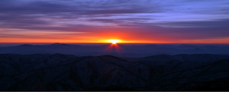

**True Dawn Figure.3**

Currently most Muslims utilize websites and mobile apps to determine the prayer and fasting time, these applications can differ by at least 30 minutes based on what application one choose to use and what solar angle of elevation that application is using as shown in table.1.

The goal of this project is to eliminate confusion produced by multiple calculation methods, standardize the calculation process and provide Muslims throughout the world with a better alternative solution for prayer time calculation method. A solution that will have higher precision and accuracy while always staying within the teaching and the guideline of the Quran and Sunnah.

The Project Fajr will start first as a pilot project with only a couple data capture pointes in the beginning and we hope to expand it world wide in the future inshallah. The pilot project will integrate a network of cameras, light sensors, light diffraction lenses, routers/switches and server machines that will host applications and algorithms that will be interfacing all these equipment. The cameras will replace the human senses by implementing image recognition and computer vision technology and the light sensors and light diffraction elements will help with overcoming the visibility issue such as tall building and weather conditions. Project will monitor and analyze the feed from cameras and sensors to determine the exact prayer time as shown in figure.4.

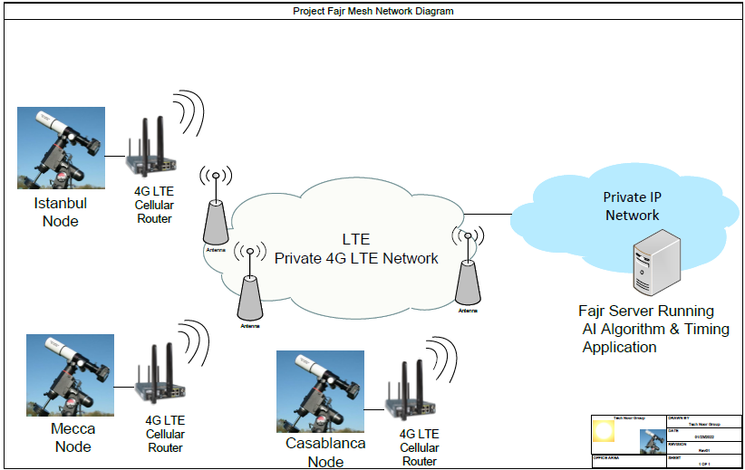

**Sensors and Cameras Network Diagram Distribution Pilot Test Figure.4**

## 4[. How](https://www.al-islam.org/articles/al-fajr-sadiq-new-perspective-sayyid-muhammad-rizvi#1-introduction) current applications calculate Fajr time

Many Muslims throughout the world utilize websites and mobile apps to determine their prayer and fasting time. Hidden in the settings of these programs is an option to choose the ‘**calculation method**’ for the angle of Fajr and ʿIshā’. The app ‘pray watch’ for iOS is a good example showing eight different methods:

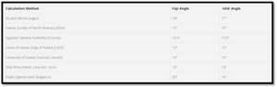

**Calculation Method Table.1**

Most users of these applications, and even scholars, may be unaware what these numbers represent and which method to select. In fact, often people may never even notice the option to change the calculation method and just use the default preset for each program/app.

Some users might choose the country they live in, falsely assuming these calculations were meant for their specific region. So, someone living in Morocco may choose UOIF and another person living in America may choose ISNA. Yet another group of users might falsely assume that different calculation methods represent most scholars living in a specific country. So someone who trusts Egyptian scholars to be more accurate in their research on Islam may choose the Egyptian General Authority of Survey, even if they live in America, and another fellow American might choose the University of Islamic Sciences, Karachi if they think the scholars of Pakistan are more diligent and reliable. Both assumptions are completely unfounded.

The impact of these differences on the timing of the prayers can be very significant. At 20° for Fajr in Anaheim, California the time enters at 4:01 AM while using 12° results in 4:49 AM. That is a difference of **almost an hour**. In a region even further away from the equator like Vancouver, Canada the difference can reach almost two hours. It is important to understand how these angles came to be used and to what extent they accurately predict the correct timings of prayer.

## [5.](https://www.al-islam.org/articles/al-fajr-sadiq-new-perspective-sayyid-muhammad-rizvi#4-science-twilights) Replacing Human Senses with Image Sensor

## 

## 1. Camera Interface and Data Acquisition (TBD)

## 2. Computer Vision/ Image Recognition Algorithm (TBD)

## 3. Image Recognition Model Calibration and Testing (TBD)

## [6.](https://www.al-islam.org/articles/al-fajr-sadiq-new-perspective-sayyid-muhammad-rizvi#4-science-twilights) Overcoming Obstructions and Weather Conditions

## Light Sensor

Links to design and software files used in this project are open source and will be later added and constantly updated as we progress in this project.

The light sensor/spectrometer we choose to use this project is the C12880MA made by Hamamatsu company, it is CMOS image sensor chip integrated with optical slit

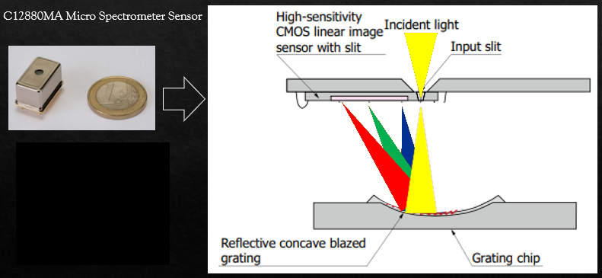

**C12880MA Micro Spectrometer Figure.5**

C12880MA Spectrometer Sensor connected with Arduino can measure light intensity of sun visible light and its wavelength that we are interested in 400 nm to 700 nm with a resolution with a resolution of 15 nm which good enough for this project.

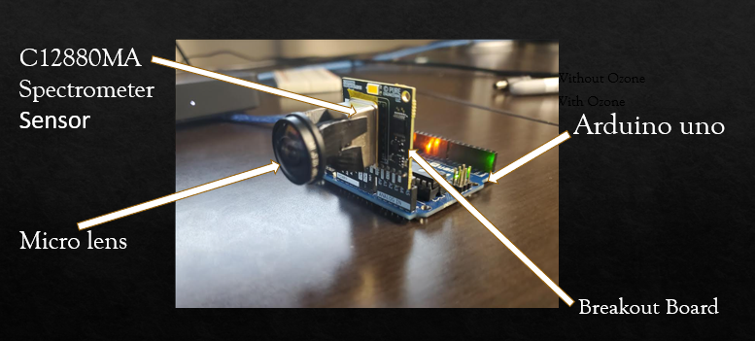

**Spectrometer and Arduino Connection Figure.6**

## 2. Diffraction of Visible light and Sensor Circuit Board (TBD)

## 3. Wavelengths & Spectral Analysis of Visible Light (TBD)

## 4. Image Fajr and it Spectral Data Representation (Fingerprint)

## 5. Testing and Calibration of Fajr Fingerprint (TBD)

## [7.](https://www.al-islam.org/articles/al-fajr-sadiq-new-perspective-sayyid-muhammad-rizvi#4-science-twilights) Project Deployment (TBD)

Note: This project just started, we will be updating this document as we go.

## 

## [4. Related Video Links](https://www.al-islam.org/articles/al-fajr-sadiq-new-perspective-sayyid-muhammad-rizvi" \l "1-introduction" \t "_blank)

<https://youtu.be/tjy-hMDhnqg>

<https://youtu.be/DhQ_TCIxlY4>

<https://youtu.be/ZhbIVlCS_-E>

<https://youtu.be/LOs9QyPcDOc>

<https://youtu.be/eKEb9GaplTw>

<https://youtu.be/FZww1Km_Th4>

<https://youtu.be/guzG7qsS8Ac>

### **I need to convert each pixel data of the image sensor into wavelength data. How can I do it?**

The relation between each image sensor pixel and the wavelength can be calculated by using the following 5-order approximate expression.  
  
Wavelength [nm] = a0 + a1pix1 + a2pix2 + a3pix3 + a4pix4 + a5pix5  
a0～a5: wavelength conversion factors listed on final inspection sheet  
These wavelength conversion factors are internally stored in mini-spectrometers (other than head type mini-spectrometers).  
pix: any pixel number (1 to last pixel) of image sensor  
  
The evaluation software can use these factors to display data converted into wavelengths.  
Please be aware that the values calculated with this approximate expression may show a slight difference when comparing with the known wavelengths of spectral lines.

### **Can mini-spectrometer A/D-converted values be converted to light levels?**

This is not possible because the mini-spectrometer does not have coefficients for converting A/D-converted values to light levels.

### **Are user's manual and technical information also provided?**

When the evaluation software is installed in the PC, the user's manual and technical information are also stored in the PC.  
To view these items, from the Windows Start menu, select:  
[Program]→[Hamamatsuminispectrometer]→[Document]

### **Are optical fibers for connecting to mini-spectrometers available?**

The following optical fibers are available (sold separately).  
  
\*A15362-01: for UV to visible, 600 µm core diameter, 1.5 m long, with SMA connector on both ends  
\*A15362-02: for UV to visible, 800 µm core diameter, 1.5 m long, with SMA connector on both ends  
\*A15363-01: for visible to NIR, 600 µm core diameter, 1.5 m long, with SMA connector on both ends  
\*A15363-02: for visible to NIR, 800 µm core diameter,1.5 m long, with SMA connector on both ends  
  
Note: MS series and micro-spectrometers do not require an optical fiber since they are designed to measure light that is incident through air.

### **How often is wavelength calibration needed? How can I do it?**

Hamamatsu mini-spectrometers have no moving parts and so possess excellent stability. We think there is no need to perform wavelength calibration when used under normal environment such as an indoor area. You can continue using the wavelength conversion factors that are attached at the time of shipment.  
Wavelength precision can be checked using calibration lamps that emit already known spectral lines. To reacquire wavelength conversion factors, we recommend using a high-precision monochromator.

### **What type of grating is incorporated in mini-spectrometers.**

Our mini-spectrometers use a transmission type grating or reflection type grating.